Accessories

Aluminium Blind Rivet – Zinc plated pin
Description Net Price/Excl Vat
Box of 1000 Qty 3.2mmØ x 10mm €11.90 per Box

Screws
Description Net Price/Excl Vat
Box of 1000 Qty 7mm Hex Head 4.2Ømm x 13mm €12.00 per Box

Drill Bits
Description Net Price/Excl Vat
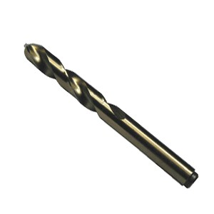 Box of 10 Qty 3.2Ømm Stubby drill bit €3.80 per Box

Hook & Toggle Clips – Steel Zinc Plated
Description Net Price/Excl Vat
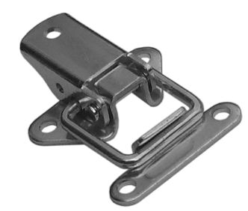 Box of 100 Qty №25 Toggle & Hook €32.00 per Box

Lacing Wire
Description Net Price/Excl Vat

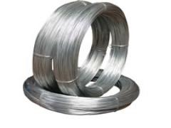 1No coil 100gr/0.65mm €1.00 per coil

Mat-hooks
Description Net Price/Excl Vat
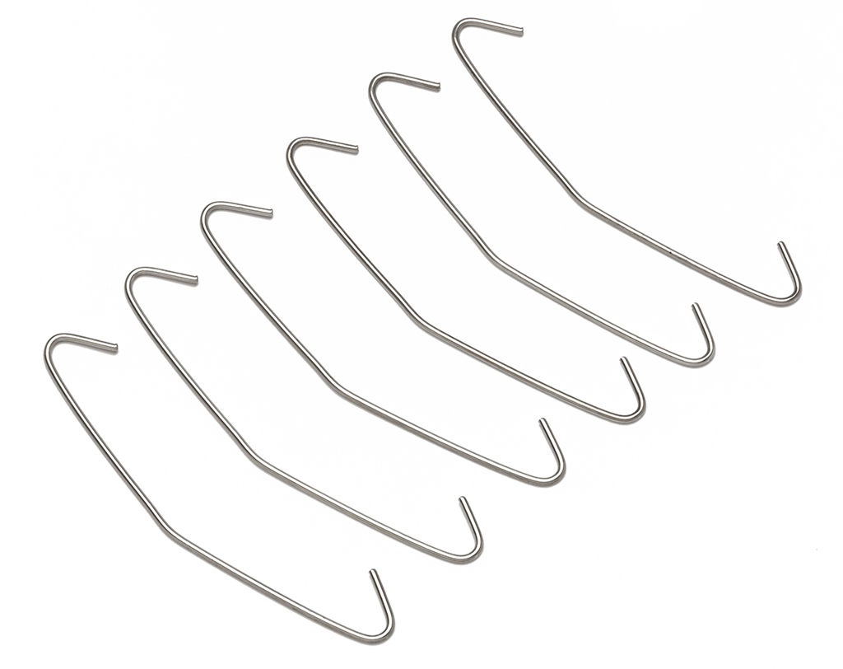 1No bag/ 100pcs galvanized 2x115mm €8.00 per bag

Notes:
- Prices shown excl Vat @ 23%.
- 3 working day turn around on all orders.
- Collection only.
- Payment on collection of goods.
- All major credit cards accepeted
- All other sizes available on request.

Kind Regards

K.G. Insulations Ltd.
Unit 13 Westpoint Bus Pk,
Mulhuddart, Dublin 15.
Tel: 01-8225875 Fax: 01-8225886 Email: kginsul@indigo.ie

